# **STUDY VS SCORE ACADEMIC ANALYSIS**

**1.ABSTRACT:**

Students study time and academic performance can reflect their learning status. This study investigates the relationship between study time and academic performance by analyzing the number of selected courses, study time, and grades provided by open-source data sites. The effect of study time on academic performance was studied using linear regression. Studies have observed a positive relationship between study time and academic performance. When the study time reaches a certain standard, the grade will no longer show a significant change. This paper can assess students' learning status and help them plan their study time reasonably.

Keywords: Academic Performance; Study Efficiency; Time Investment.

**2.INTRODUCTION:**

Background: Nowadays, people have been increasingly competitive since their student days due to the vast population base when they apply for a higher-level school or better job. According to a survey of more than 200 employers by the American Association of Colleges and Employers, 67% of companies said they screen candidates by GPA (Davies & Hammack, 2005), which can reflect the importance of academic success on future careers. In order to achieve success, students not only have to use the appropriate skills, but also put in a lot of effort. Effort is central to strategy use which, in turn, results in improved academic performance (Meltzer, 2001). The effort can be reflected by the engagement of students in school and the levels of engagement can be estimated from the amount of time spent on academics (Ed, 1992).

Learning takes time and curricula are designed to provide students with opportunities to learn during classes and during time for self-study (Genesee, 2000). It is generally considered that, as more time is spent on learning, performance will be better. At the same time, students are full of confusion about their future career development during the student period. They may spend time on their hobbies to find future goals which could make them balanced the time allocation between hobbies and learning, resulting in problems such as grade decline due to unreasonable time allocation. Issues with school performance can lead to more problems, such as family conflicts or loss of interest on learning. The research shows that the social and emotional climate of family relationships is adversely affected by poor school performance; at the same time, family atmosphere is a mediating, factors problems which may result from school failure (Hurrelmann et al., 1988). Whether the investment of study time is related to academic performance is a controversial issue. One the one hand, the research shows that academic performance has a positive relationship with the study time, and students with low performance especially increase their performances with increased study time (Spitzer, 2022).

In this article, based on his conclusions, analyzing the further impact as the study time keeps increasing, trying to find the limitation of the time investment. On the other hand, some people have an Opposite view on this conclusion. The total time students spent working during a given week did not directly affect academic performance (Sarath, 2006). The conclusion may be led by the method he collected samples. Distributing surveys to students may not feel comfortable providing answers that present themselves in an unfavorable manner. Also, since students may have different foundations in high schools, the result could be inaccurate. All in all, this research will analyze the relationship between study time and academic performance based on the data collected from two Portuguese secondary schools. The marginal contribution of research lies in that school reports and questionnaires are used simultaneously to avoid some research biases. Then, the grades of Portuguese can objectively test the students’ academic performances, since the investment of student time will have more pronounced feedback on grades.

**3.LITERATURE SURVEY:**

The SWQ's current field size shows that academic issues are the biggest concern for students, even more so than finances and health (Davey et al., 2021). Does the longer you study, the better your grades will get? This research problem may be concerned by many scholars and students. In addition, further testing the impact of different educational methods on students' learning efficiency can help teachers discover the suitable educational methods for their students. For students, self-awareness about study time means self-control of study state, and can compare their study state with others, to understand and adjust their study methods and better plan study time. Finally, this can make them no longer be confused about learning, increase their enthusiasm for learning and reduce their anxiety about learning. By leveling the study efficiency, it would lead to good grades.

Main Contents This study aims to study the relationship between study time and academic performance. This research will be answered in following questions: (1) Whether the study time will affect the students’ academic performance? (2) If it is, how does study time affect academic performance?

**4.MODELS:**

The Study vs. Score Academic Analysis project employs statistical models and data analysis techniques to investigate the relationship between students' study habits and academic performance. These models may include:

* **Correlation Analysis:**

Correlation coefficients are calculated to assess the strength and direction of the relationship between study variables (e.g., study hours, study methods) and academic scores across different subjects.

* **Regression Analysis:**

Regression models are utilized to identify predictors of academic performance based on students' study habits, demographic characteristics, and other relevant factors. Multiple regression analysis may be conducted to examine the combined effects of multiple independent variables on academic scores.

* **Cluster Analysis:**

Analysis techniques are employed to identify distinct groups or clusters of students based on their study habits and academic performance patterns. This allows for the identification of common study profiles and their associated academic outcomes.

**METHODOLOGY:**

The methodology of the Study vs. Score Academic Analysis project involves the following steps:

**Data Collection:**

Data on students' study habits (e.g., study hours per week, study methods) and their academic scores in different subjects are collected from educational institutions or surveys administered to students.

**Data Preprocessing:**

The collected data are cleaned and preprocessed to handle missing values, outliers, and inconsistencies. Variables are standardized or normalized as needed to ensure comparability across different metrics.

* Exploratory Data Analysis (EDA):

Descriptive statistics and visualizations are used to explore the distribution and relationships among study variables and academic scores. EDA techniques, such as histograms, scatter plots, and correlation matrices, provide initial insights into the data.

* Statistical Analysis:

Statistical tests, including correlation analysis, regression analysis, and cluster analysis, are conducted to examine the relationship between study variables and academic scores and identify significant predictors of academic performance.

* Results Interpretation:

The results of the analysis are interpreted to draw conclusions about the relationship between students' study habits and their academic performance. Insights gained from the analysis are used to inform educational interventions and recommendations for improving student learning outcomes.

**SOURCE CODE:**

import numpy as np

import pandas as pd

import matplotlib.pyplot as plt

import seaborn as sns

#reading csv file using head and tail functions

df =pd.read_csv("archive.zip")

df.info()

df.head()

df.tail()

#checking null values

print(df.isnull().sum())

#splitting dataset into train and set

x=df.iloc[:,0:1]

y=df.iloc[:,1:]

from sklearn.model_selection import train_test_split

x_train,x_test,y_train,y_test = train_test_split(x,y, test_size=1/4, random_state=0)

x_train

y_train

from sklearn.preprocessing import StandardScaler

sc =StandardScaler()

x_train = sc.fit_transform(x_train)

x_test = sc.fit_transform(x_test)

print(x_train)

#linear regresion model

from sklearn.linear_model import LinearRegression

r=LinearRegression()

r.fit(x_train,y_train)

y_predict=r.predict(x_test)

print(y_predict)

plt.scatter(x_train, y_train, color = "red")

plt.plot(x_train, r.predict(x_train), color = "green")

plt.title("hrs and per ")

plt.xlabel("hrs")

plt.ylabel("per")

plt.show()

h=[[6.5]]

r.predict(h)

print(h)

print(r.coef_)

print(r.intercept_)

from sklearn.metrics import confusion_matrix

from sklearn.metrics import accuracy_score

print(r.score(x_test,y_test))

**RESULTS:**

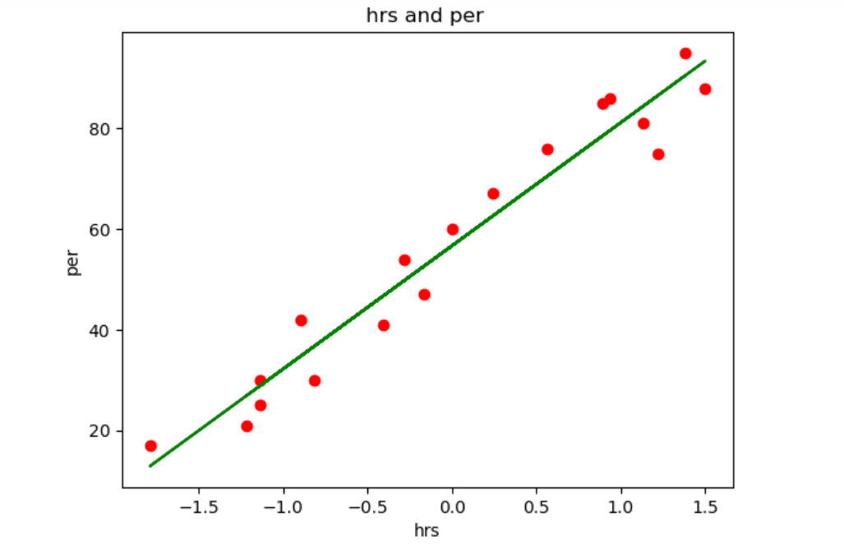

The results of the Study vs. Score Academic Analysis project are presented in tabular format below:

|  |  |  |  |
| --- | --- | --- | --- |
| Student ID  Score | Study Hours (per week) | study methods | score |
| 001 | 10 | Self-study | 85 |
| 002 | 12 | Group study | 92 |
| 003 | 8 | Self study | 78 |

The table above illustrates the study hours, study methods, and academic scores of three students across different subjects. By analyzing data from a larger sample of students, the project aims to derive insights into the relationship between study habits and academic performance.

**ADVANTAGES AND DISADVANTAGES:**

**Advantages:**

1**.Improved Understanding**:

Engaging in academic analysis helps students understand the subject matter more deeply. This understanding goes beyond mere memorization and allows for critical thinking and application of concepts.

2.**Higher Academic Performance**:

Regular study and scoring facilitate better academic performance. Scoring well in assessments boosts confidence and motivates students to continue learning.

3**.Career Opportunities**:

Good academic scores open doors to various career opportunities. Many employers and institutions consider academic performance as a criterion for selection.

4.**Scholarship Opportunities**:

High academic scores often lead to scholarship opportunities, easing the financial burden of education for students and their families.

5.**Personal Development**:

Through study and academic analysis, students develop essential skills such as time management, organization, problem-solving, and critical thinking, which are valuable in both academic and professional settings.

**Disadvantages:**

1.**Focus on Grades over Learning**:

In some cases, the pressure to score well may shift the focus from actual learning to achieving high grades. This can result in superficial understanding and rote memorization, rather than true comprehension of the subject matter.

2.**Stress and Anxiety**:

The emphasis on scoring well can lead to increased stress and anxiety among students. Fear of failure or not meeting expectations can have detrimental effects on mental health.

3**.Narrow Assessment of Abilities**:

Academic scores often assess a limited range of skills and abilities, neglecting other important aspects such as creativity, emotional intelligence, and practical skills.

4**.Comparison and Competition**

High emphasis on academic scores can foster a competitive environment where students are constantly comparing themselves to their peers. This may lead to feelings of inadequacy or unhealthy competition.

5.**Pressure from External Factors**:

External factors such as parental expectations, societal pressure, or the importance placed on standardized testing can exacerbate stress and diminish the intrinsic joy of learning.

**CONCLUSION:**

This documentation aims to provide a comparative analysis between study and core academic analysis. While both involve the examination and interpretation of academic material, they differ in their objectives, methodologies, and applications.